Unit 12 Assignment Instructions – CIS164 
For the Unit 12 Assignment we will be working with CSV files. CSV files allow you to store large amounts of data in a comma separated format that can be easily parsed.
Please make sure to fully read each question to ensure that you answer each question per the requirement. Also, please ensure that all responses are in complete sentences, free of spelling and grammatical errors.
*Unit 12 Grading Rubric (45 Points):
Assignment Requirements | Maximum Points | Points Earned
1. Writing to CSV Files | 0-25 Points
2. Reading CSV Files | 0-20 Points
Points Deducted for Spelling or Grammatical Errors
Total (Sum of All Points)
*Directions for Submitting Your Assignment:
Complete your assignment ensuring all questions are answered based on the assignment requirements. When the Unit 12 assignment is complete, please save your file in the following format, “Lastname-Unit#.doc” (Example: Smith-Unit12.doc). You may also utilize a Word Processing software such as LibreOffice for assignment completion. In this case the assignment may be saved in .odt format, (Example: Smith-Unit12.odt). Then when ready submit your file to the “CIS 164 – Unit 12 Submit Assignment” activity for grading.

1. Writing to CSV Files
- Start the PyCharm IDE. Select “File->New Project” on the next screen, then under “Location” change the word “untitled” to “Unit12”. Then click the “Create” button.

- Highlight your project “Unit12” then right click. When you right click a menu will appear, from this menu select New->Python File. Then a dialog box will appear, in the “Name” field of the dialog box type “CSVwrite.py”.

- Create a CSV file utilizing the csv library, named ‘cochise.csv’. It should have four different rows. The rows within the CSV file should be the following in order:

Cochise, College, Online
CIS, 164, Python, Programming
Cochise, College, Sierra Vista, Campus
Hello, World!

Provide a screenshot of your script’s output when run, and also provide your code within this document copied and pasted from your file.

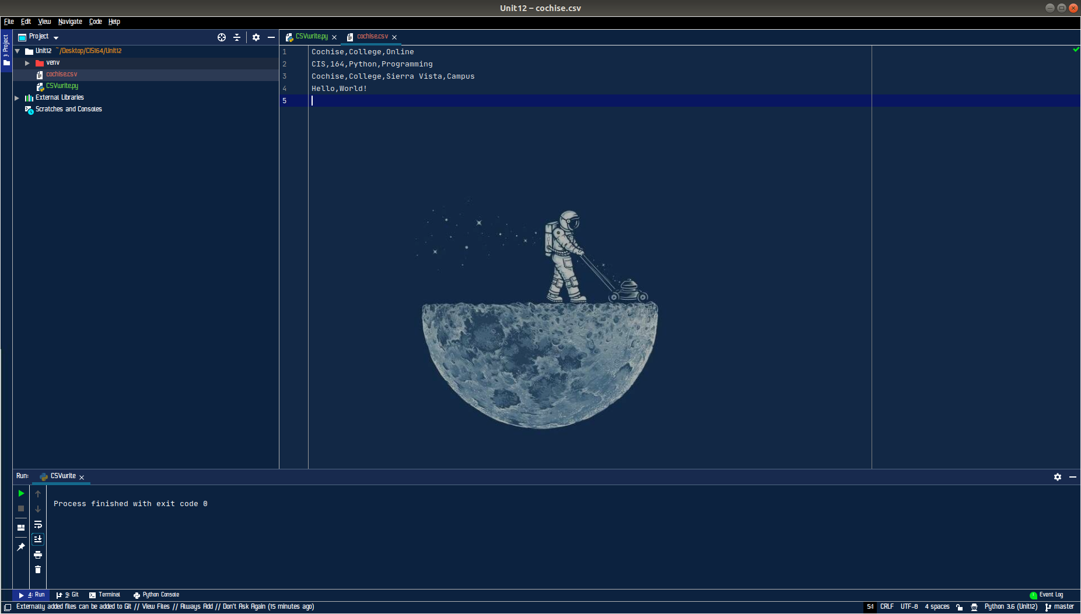

import csv
csv_file = open('cochise.csv', 'w', newline='')
csv_writer = csv.writer(csv_file)
csv_writer.writerow(['Cochise', 'College', 'Online'])
csv_writer.writerow(['CIS', '164', 'Python', 'Programming'])
csv_writer.writerow(['Cochise', 'College', 'Sierra Vista', 'Campus'])
csv_writer.writerow(['Hello', 'World!'])
csv_file.close()

2. Reading CSV Files
- Highlight your project “Unit12” then right click. When you right click a menu will appear, from this menu select New->Python File. Then a dialog box will appear, in the “Name” field of the dialog box type “CSVread.py”.

- Create a python script that displays the contents of the ‘cochise.csv’ file created earlier utilizing the csv library. Provide a screenshot of your script’s output when run, and also provide your code within this document copied and pasted from your file.

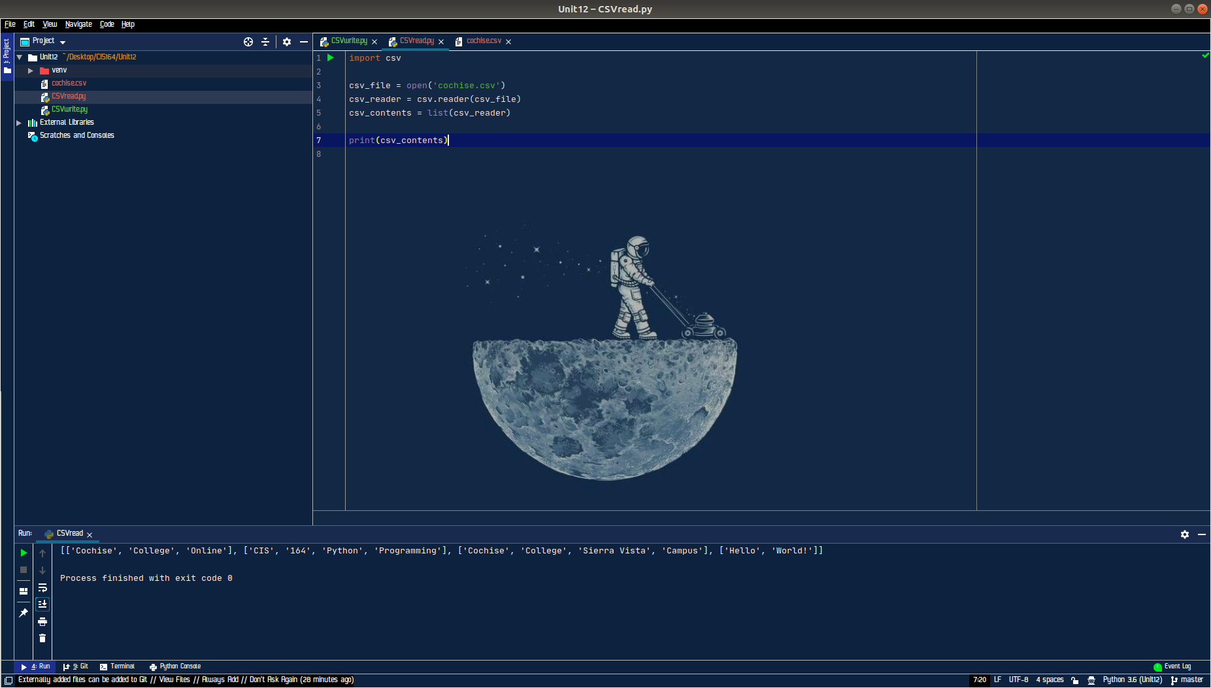

import csv
csv_file = open('cochise.csv')
csv_reader = csv.reader(csv_file)
csv_contents = list(csv_reader)
print(csv_contents)

